  Injury assist system | Abstract  Sports Injury Management System helps athletes track injuries and book medical appointments through a Java Swing interface. Users create secure accounts, select their sport and injury details, and receive automated medical reports with treatment recommendations. This project streamlines patient-doctor communication with clean data management.  Dr/Waffa Moheb  Object oriented programming  Yassin Mohamed Ali 241006978  Omar Sherief Abu Ramadan 241004341  Shahd Ibrahim 241014026  Youssef Khaled 241004324  Ahmed Mo’men 241004732

introduction to the injury assist system:
injury assist system’s role is providing essential and fast support during critical unexpected injuries, minimizing the risks associated with delayed care ensuring that injuries are properly assessed and given a topical treatment preventing them from worsening.

Our motivation:
- To help categorize the injuries and easier the process of diagnosis to the doctors.
- Make a helpful report to all patients that can help them in their future life.

Functions of injury assist:
- Determine the injury type and its severity level .
- Assist the injury type with a suitable treatment.
- Booking system for booking appointments.
- Save the patient data and make a summarized report for each patient.

UML
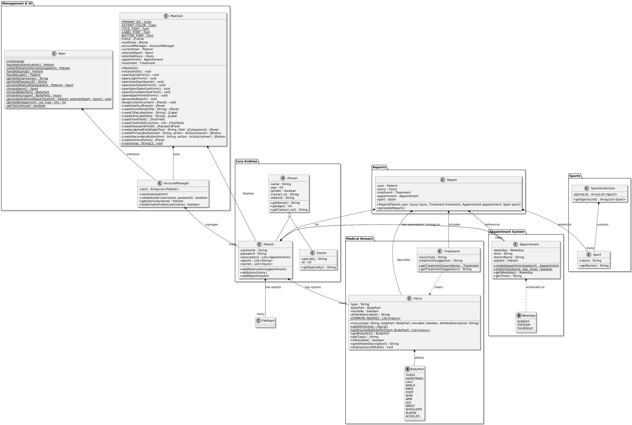

WE USED THE INHERITANCE IN LINKING THE PERSON CLASS WITH THE Patient
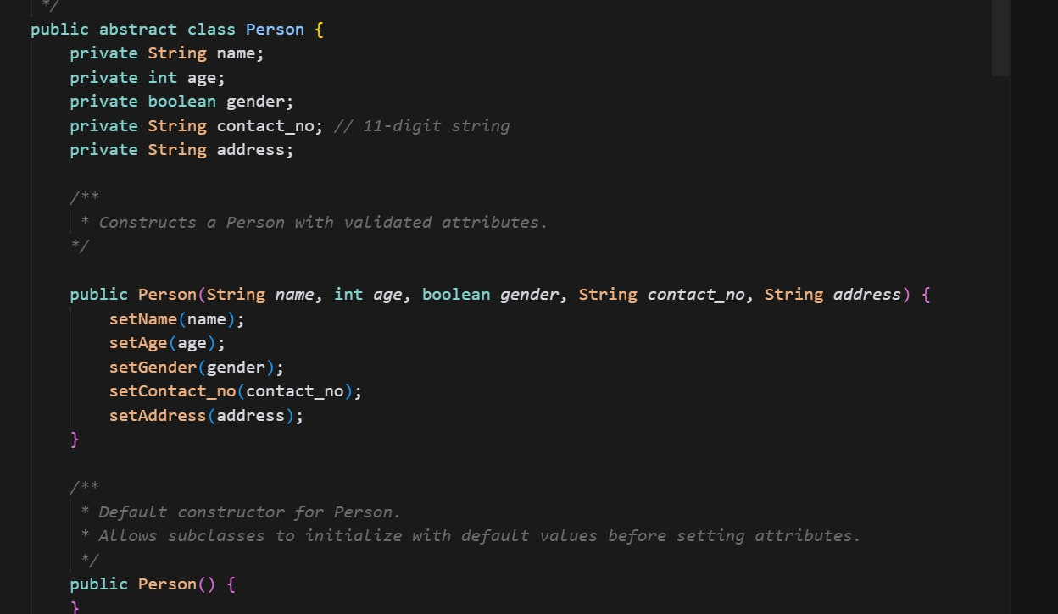

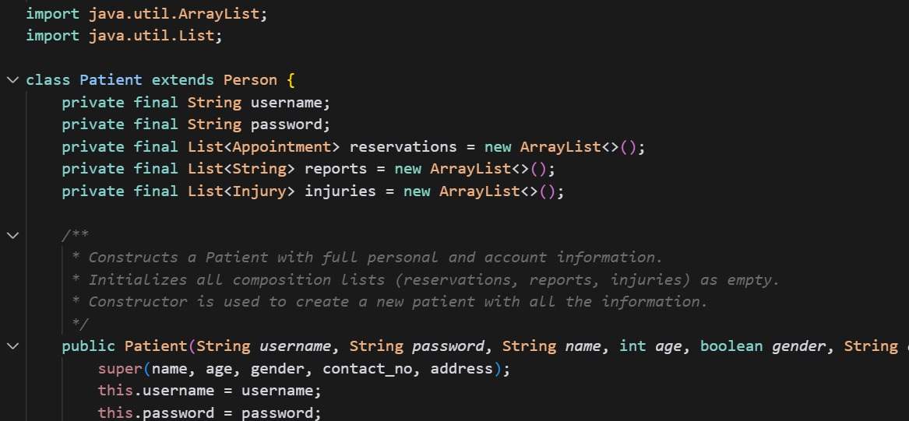

WE USED THE ENCAPSULATION IN HIDING THE INTERNAL DATA OF ALL OF OUR ATTRIBUTES.

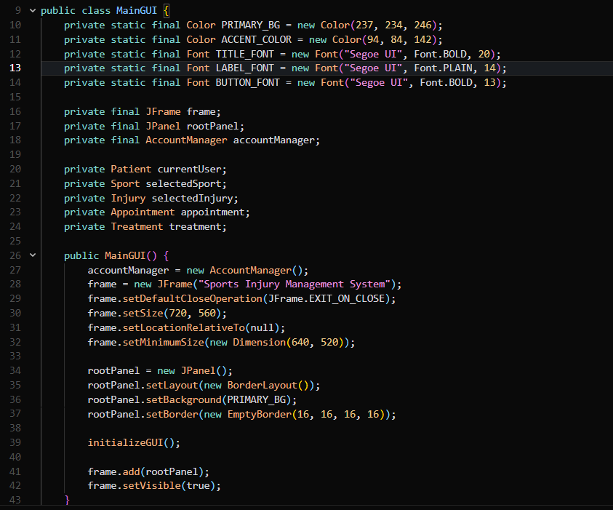

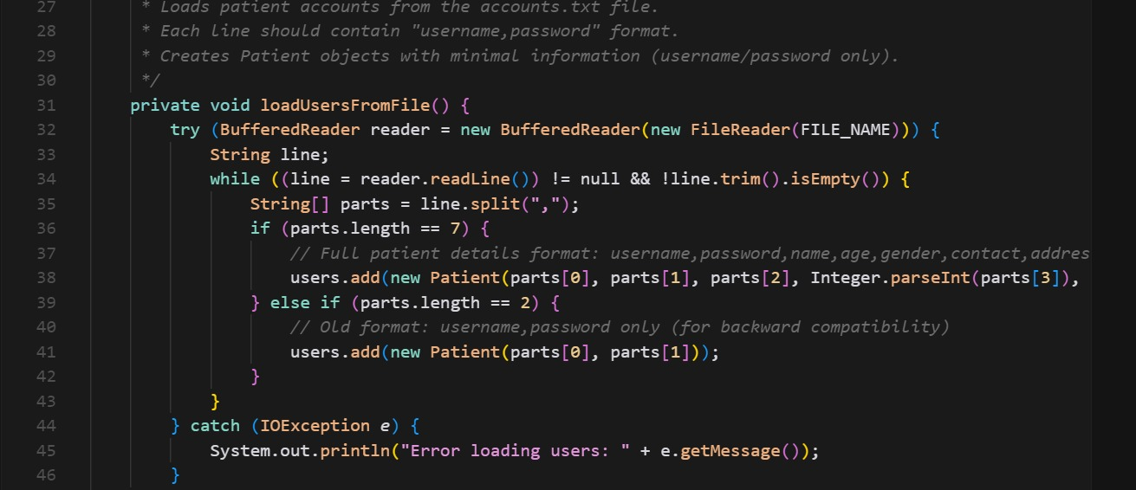
We used the files and exceptions to control the login form & signup form as the data of the users are saved in the file and the exception ensure that the account is correct
An abstract class in Java is a class you can't create objects from. It can have methods with or without a body and is meant to be extended by other classes.

We did an abstract method to generate customer report.

Validation is the process of checking if input or data meets specific rules, requirements, or standards before being processed or used.

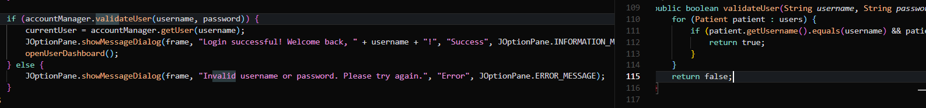
Used the validation to make sure that the logged in user name and password the correct

We then used the composition most in the report class

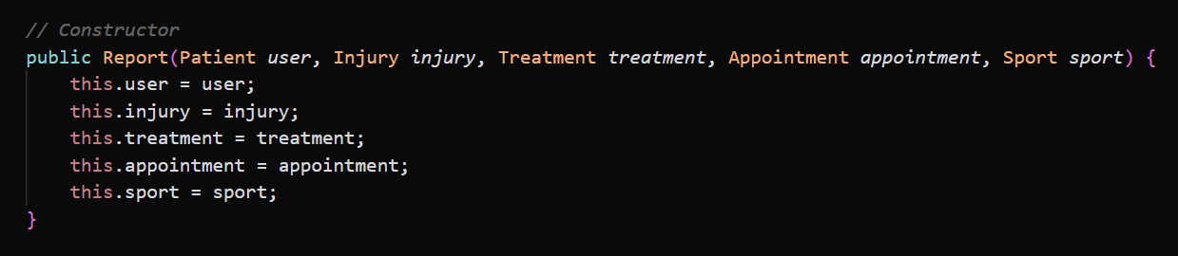
The output

